***Experiment 7***

**Aim:** Data Visualization with Python and Matplotlib: Use Python and Matplotlib library to visualize insights extracted from large datasets, such as plotting histograms, scatter plots, or time series data.

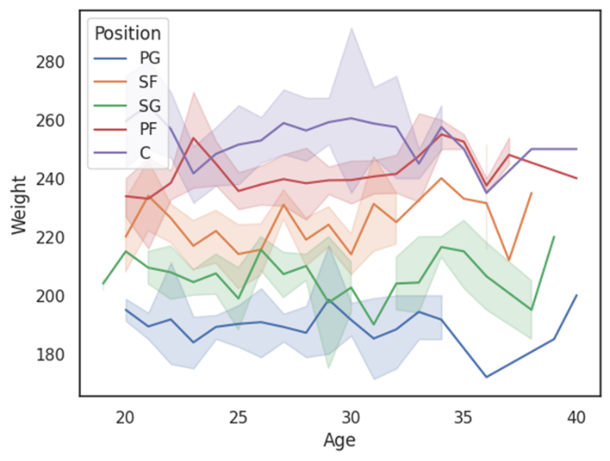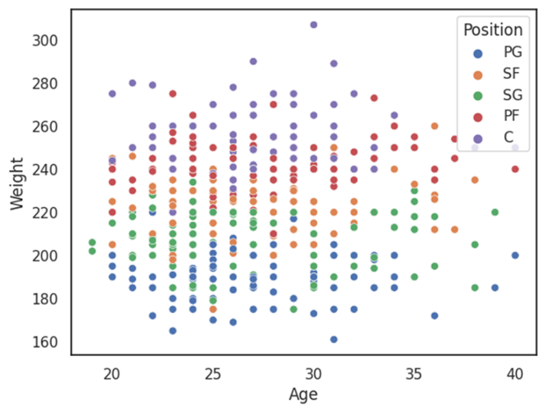***Dataset Exploration and Visualization:***

***-8***

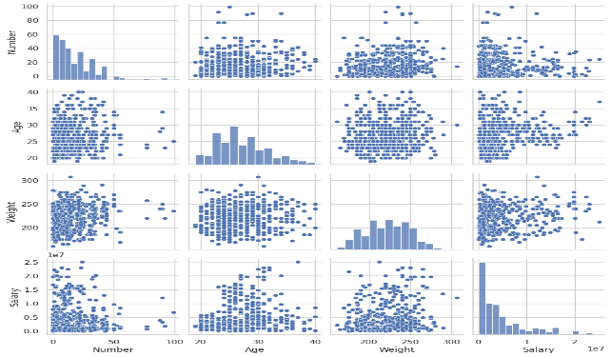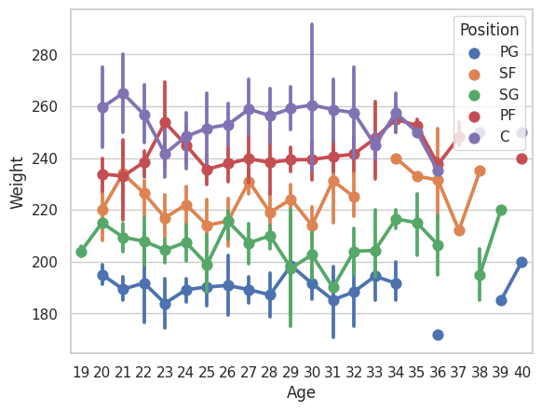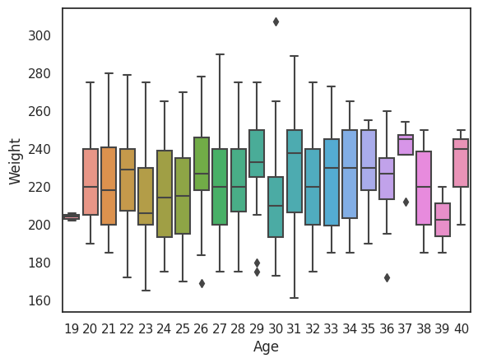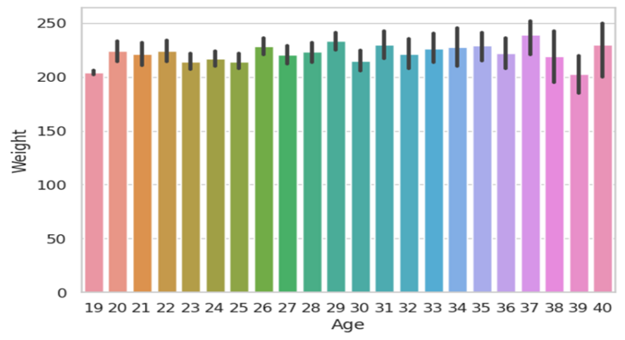

***Fig 6: Pair Plot of Dataset***

***Fig 5: Point Plot of Age and Weight***

***Fig 4: Box Plot of Age and Weight***

***Fig 3: Bar Plot of Age and Weight***

***Fig 1: Line Plot of Age and Weight***

***Fig 2: Scatter Plot of Age and Weight***